**Department of Systemics**

**School of Computer Science**

University of Petroleum and Energy Studies

cid:image003.png@01D81F60.F8BDA810

**ADVANCE DATABASE MANAGEMENT SYSTEM**

**LAB FILE**

Submitted by

**Akshat Negi**

**R2142220414**

**Batch - 2**

B.Tech Computer Science and Engineering(CSF)

Submitted to

**Dr. KOTHA VENUGOPALCHARY**

Assistant Professor (SS)

SOCS, UPES

**LAB EXPERIMENT – 8**

**Aim:** To understand the concepts of Sequence, PL/SQL programming, and function and procedure in PL/SQL.

**Objective I:** Students will be able to implement the concept of sequence.

*1) Create a sequence by name EMPID_SEQ starting with value 100 with an interval of 1*

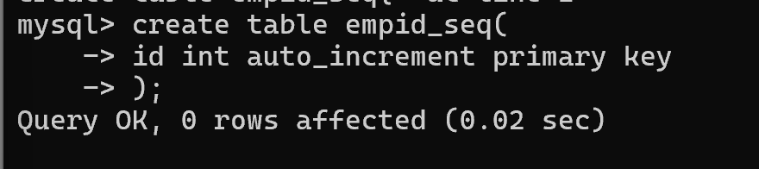

*2) Write a SQL command for finding the current and the next status of EMPID_SEQ.*

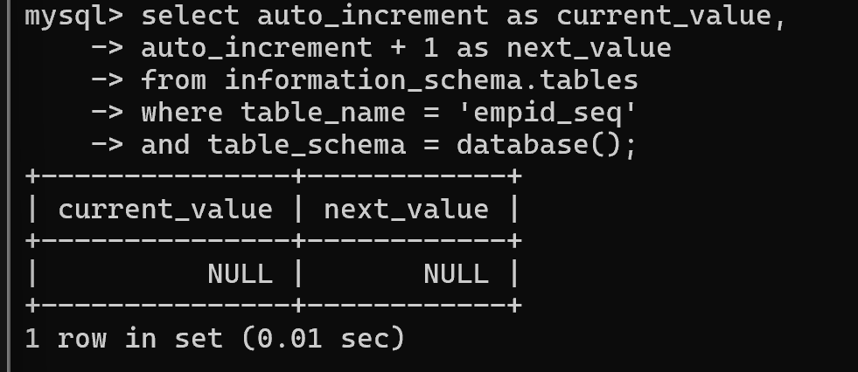

*3) Change the Cache value of the sequence EMPID_SEQ to 20 and maxvalue to 1000. Insert values in the employees table using sequences for the employee_id column.*

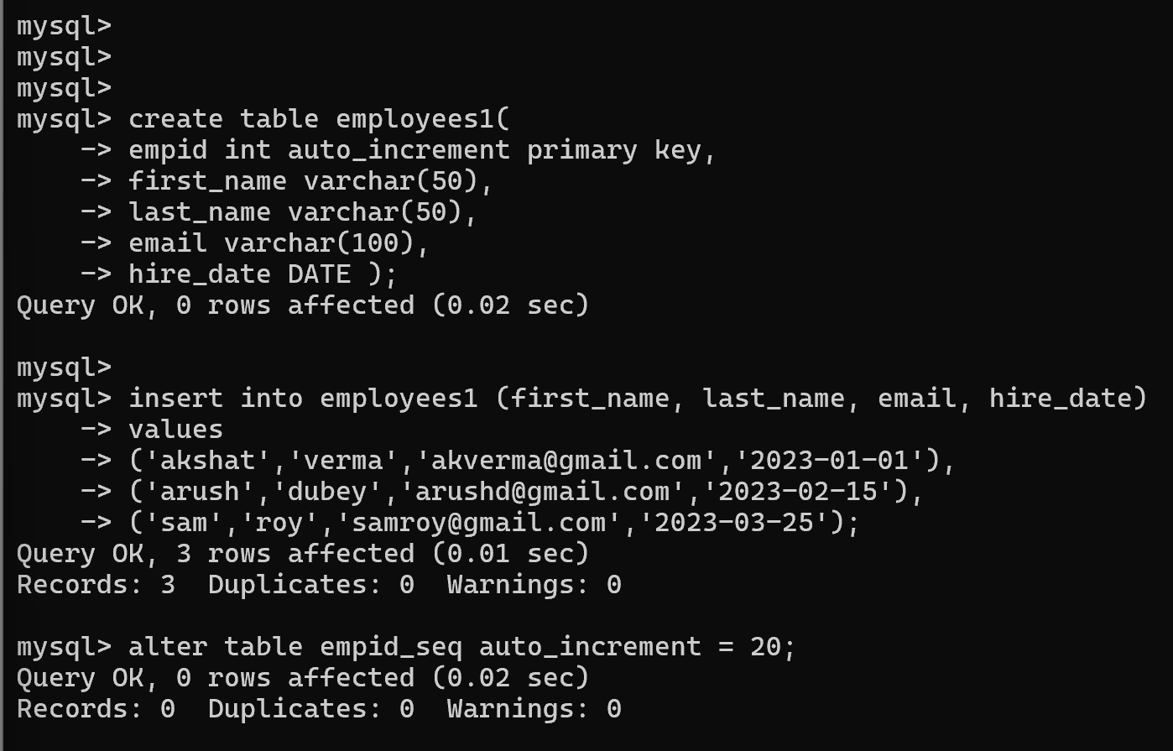

*4) Drop sequence EMPID_SEQ.*

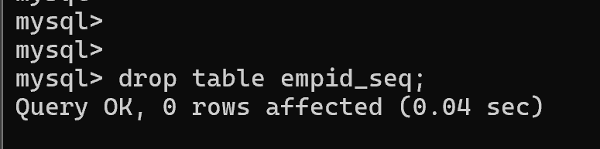

*5) Create a sequence called REVERSE to generate numbers in the descending order from 10000 to 1000 with a decrement of 5.*

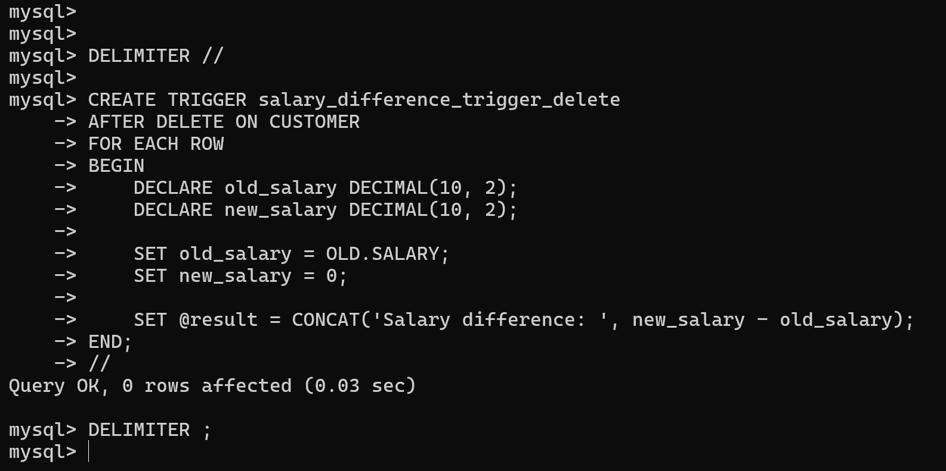

**Objective II:** Students will be able to implement the basic concepts of Pl/SQL.

1. *Write a PL/SQL code to accept the value of A, B & C display which is greater.*

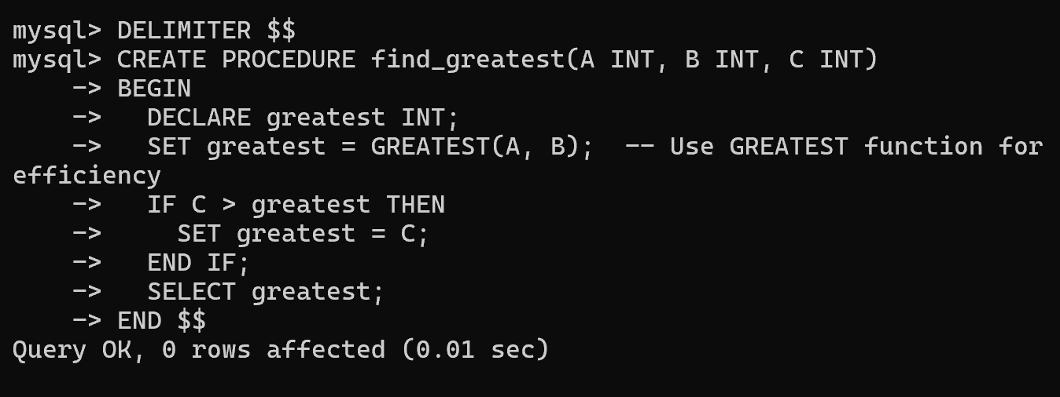

1. *Using PL/SQL Statements create a simple loop that displays the message “Welcome to PL/SQL Programming” 20 times.*

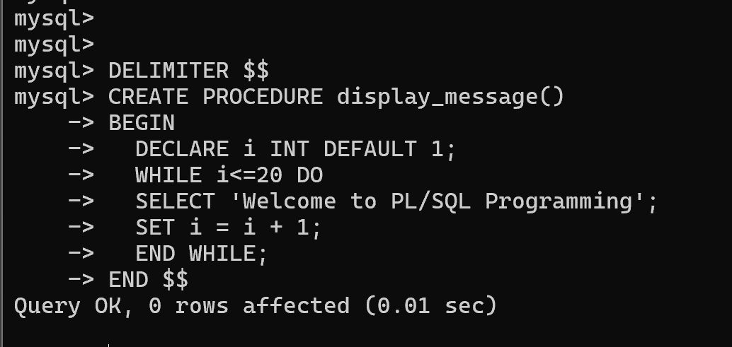

1. *Write a PL/SQL code block to find the factorial of a number.*

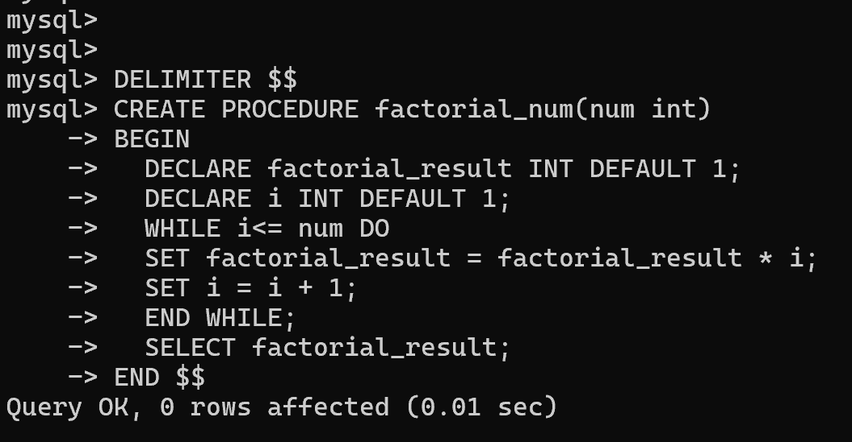

1. *Write a PL/SQL program to generate Fibonacci series.*

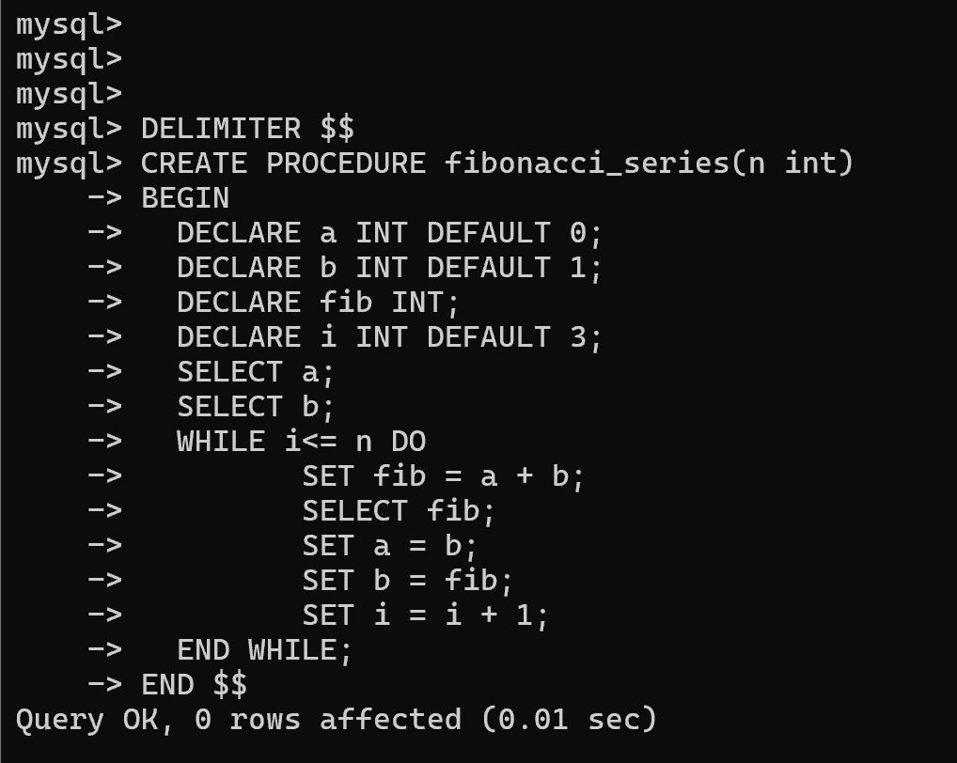

1. *Write a PL/SQL code to find the sum of first N numbers.*

